Topics > Intertopic Map
What is the visualization showing (data, time range, key variables)?
Each topic has been represented by a bubble. The size of the bubbles shows the intensity(how many times it has been used) of the topic. The distance between two topics shows how closely the topics are related.
Why is this visualization useful / what insight does it unlock?
It tells the users the topics that are primarily used and its intensity. Also the similarity between those topics.
When or by whom it would typically be used (e.g., leadership, ops team, trend tracker)?
Not fully fleshed out yet, but mental health professionals, researchers.
Comments on the current visualization:
- The bubble chart works well for this purpose. It just needs some refinement.
- The bubbles don’t have a threshold for very small sizes. As a result, the target size becomes difficult to tap.
- The hover window is not readable. Hove doesn’t work on touch devices, so it’s not recommended.

Suggestions/Proposal:

See a similar example: https://www.highcharts.com/demo/highcharts/bubble

Visualization:
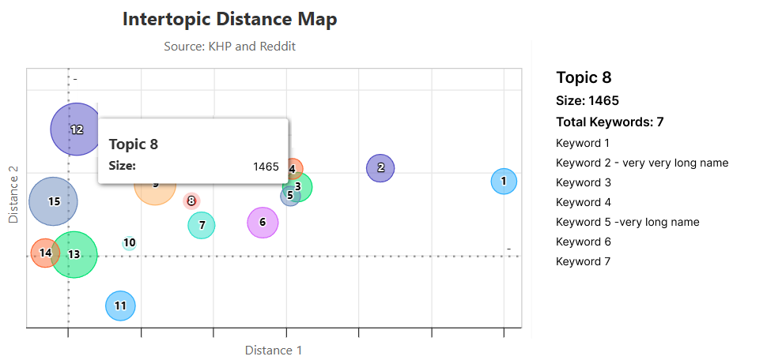

- The size of a topic bubble is based on how many times the keywords under that topic have been used
- On clicking one bubble, the right column with the topic name and list of keywords for that topic opens up.
- Hover is only active on Desktop

Questions
- The distance shows how similar or different the topics are; is that difference denoted by a number? Is there a scale on which this comparison lies?
- Topic 1: 20
  - Topic 2: 10; will topic 1 be double topic 2’s size? The size of the bubble is proportional to the size / number of times it appears

Topics > Barchart
What is the visualization showing (data, time range, key variables)?
It’s showing the ranking of topics based on how much people are talking about it.
Why is this visualization useful / what insight does it unlock?
It shows the number and frequency of keywords that appear under a topic + it allows for the user to compare different keywords.
When or by whom it would typically be used (e.g., leadership, ops team, trend tracker)?
Not fully fleshed out yet, but mental health professionals, researchers.
Comments on the current visualization:
- Showing all the bar charts at once is causing information overload.
- X-axes have different ranges. So we cannot compare the bars on one bar chart with the other.

Suggestions/Proposal:
- Show one topic bar chart at once.
- Keep the X-axes range the same to make it comparable

Visualization:
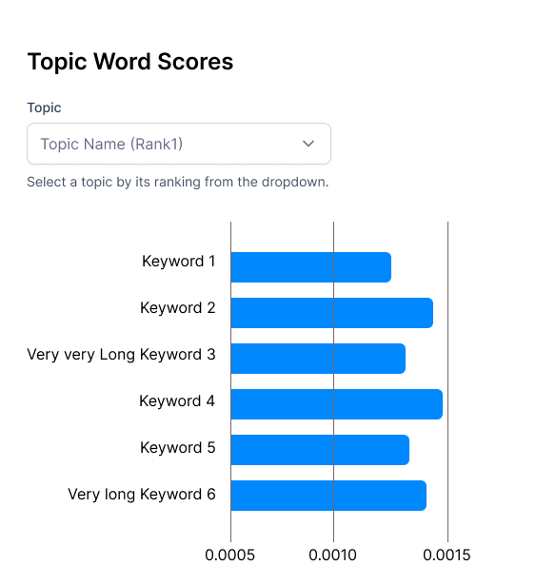
Questions
- What unit is used for the number of keywords?
  - The unit apparently changes in each topic, it should be consistent.
- How about we show comparisons between two (or more) topics, to see how many times similar keywords appear in different topics?
- How are these being ranked?
  - To rank, would it make sense for the bars to be sorted in a descending order?

Topics > Hierarchy
What is the visualization showing (data, time range, key variables)?
This chart shows the hierarchical structure of topics. Broad categories are broken down into specific sub-themes.
Why is this visualization useful / what insight does it unlock?
To be discussed with Zainab.
When or by whom it would typically be used (e.g., leadership, ops team, trend tracker)?
Not fully fleshed out yet, but mental health professionals, researchers.`
Comments on the current visualization:
- The hierarchy is not clear as the nodes are concentrated and overlapping on the chart.
- Topic names are not clear.

Suggestions/Proposal:

We can show it in the form of a Tree map with levels. This visualization will work only if we have some value attached to each topic.

Visualization: This is an indicative visualization. I am working on a chart for Climate Lens.
See a similar example: https://www.highcharts.com/demo/highcharts/treemap-with-levels

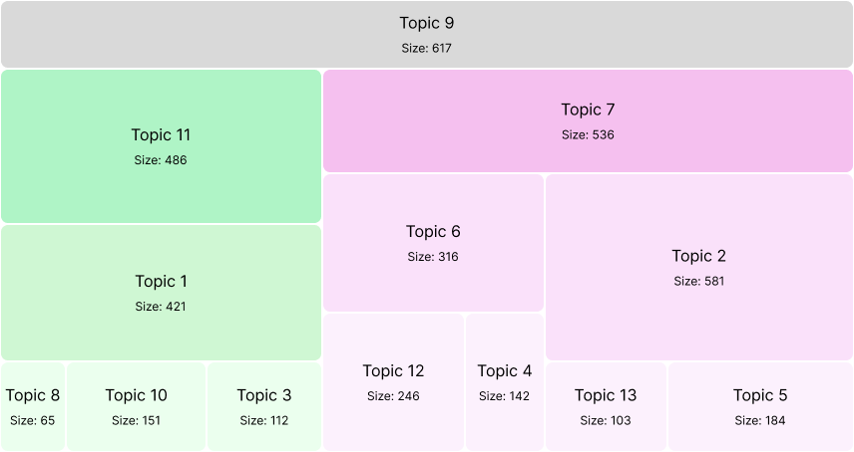

- In this treemap, Topic 9 is on the top of the Treemap. Topic 11 and Topic 7 are children of Topic 9. Topic 1 is child of Topic 11. Topic 6 and Topic 2 are children of Topic 7. Topic 12 and Topic 4 are children of Topic 6.
- The size shows how many times they were used and also defines the area on the map.
Questions
- the

Sentiments > Distribution

Comments on the current visualization:
The pie chart is too big to be legible on big screens.

Suggestions/Proposal: Keep the size of the pie chart fixed (should be legible on mobile phones). Then it would be eligible on all devices.

Sentiments > Probability

Comments on the current visualization: Can we show the interpretation from the charts? E.g. “people may be expressing worry without being strongly negative”

